Đề 12
LISTENING
PART 1
Q1 A man is calling his sister. Where are they going to meet?
A. At the station
B. At the park
C. At the university

Hi, it's me. I wanted to confirm where we're meeting today. I thought we agreed to meet at the park, right? It's a nice place to relax and catch up.

Q2 A woman is talking about her vacation. What is the relationship between the speaker and Lisa?
A. Best friends
B. Mother and daughter
C. Teacher and student

I can't imagine going with anyone else. Some people think we look like mother and daughter because we care for each other so much, but it's really just best friends hanging out. I just got back from an amazing vacation with Lisa.

Q3 Anna is calling her brother Max. What does Anna do later in the afternoon?
A. Stay late at the office
B. Pick up her kids
C. Hang out with friends

Hey Max, it's Anna. I wanted to ask you for a favor this afternoon. I have to stay late at the office to finish some work.

Could you please pick up my kids from school? After that, I know you'll want to hang out with your friends, so feel free to take them along. I really appreciate your help. Hey Max, it's Anna.

Q4 A man is talking about his trip. What did he enjoy last year?
A. Go for a walk
B. Go picnic
C. Go cycling
The views were stunning and it felt great to be outdoors. I also went for a walk a few times, but cycling really allowed me to explore more areas. We even had a picnic one day, which was lovely too.

Q5 Doctor's office is calling to change the appointment. When is the new appointment?
A. On Friday 14th
B. On Thursday 30th
C. On Thursday 13th

Hello, this is the doctor's office calling to change your appointment. I wanted to let you know that the new appointment is on Thursday the 13th. I understand you might have been expecting it to be on Friday the 14th, but we're all off this day due to the National Dentist Holiday.

Q6 A man calls the teleshop. What is the teleshop number?
A. 102030
B. 201030
C. 301020

My phone is not working. Can you remind me of the number? I think it starts with 2-0 or 1-0 or 3-0 something. Is it 1-0 2-0 3-0 or 3-0 1-0 2-0? No, wait.

I remember now. It's 2-0 1-0 3-0. I really need to order that new gadget.

Q7 Vincent is calling James. Why does Vincent call James?
A. To say hello
B. To arrange meeting
C. To suggest a drink

Q8 Two people are talking about meeting for dinner. What time does Ahmed meet Rose?
A. quarter past seven
B. half past seven
C. quarter to eight

Q9 Max is calling his friend. How much can Max pay for the computer?
A. 150 pounds
B. 250 pounds
C. 350 pounds

Q10 A man is talking to the shopping assistant. What color top does he buy?
A. Red
B. Blue
C. Black

Q11 Alice is calling her friend. What did she lose?
A. A book
B. A laptop
C. A phone

Q12 A man is talking about the city concert. How will the concert end?
A. The city's favorite group
B. Fireworks performance
C. Singing from orchestra

Q13 Jana is talking to her friend. What does Jana's sister look like?
A. Tall
B. Short
C. Curly hair

PART 2
- complete school assignments C
- learn courses
- watch film A
- communicate with friends B
- find transport information D

SPEAKER A-watch film A
I spend quite a bit of my free time online, mostly because I love watching movies. The internet makes it so easy to find a wide variety of films, from the latest releases to old classics. I can stream them directly on my laptop or TV without needing to go out and buy DVDs or rent movies.

SPEAKER B-communicate with friends B
I prefer just chatting and staying connected through messages and calls. The main reason I use the internet is to stay in touch with my friends. It's great because I can talk to people who live far away without any issues.

SPEAKER C-complete school assignments C
For me, the internet is an essential tool for completing my school assignments. I use it to research information, find articles and access educational websites that help me understand my subjects better. It's so convenient because I can find everything I need online without having to spend hours in the library.

SPEAKER D-find transport information D
It has really made studying more efficient and I can work from anywhere, whether it's at home or on the go. Whenever I need to plan a trip or get somewhere, I always use the internet to find transportation details. I can check train schedules, bus routes and even look up flights.

PART 3
Listen to two people discussing singers and music. Read the opinions below and decide whose opinion matches the statements, the man, the woman, or both the man and the woman. You can listen to the discussion twice.
- Singer can be good models for the young Woman
man/woman/both
- Taste in music is a highly personal thing
man/woman/both
- Music is a universal language
man/woman/both
- Music can be used to manipulate people's feelings.
man/woman/both

PART 4
Listen to a TV announcer talking about a writer's new novel. Choose the correct answers.
16.1 What does the announcer say about the new novel?
A. It is different from his earlier works
B. It is romantic and soft
C. It is less famous than his earlier works
16.2 What does the announcer say the writer should do in the future?
A. The writer should continue to write this genre
B. The writer should go back to his original genre
C. He should listen to critics before writing his next work.

17. A radio MC talks about a famous musician's life. Choose the correct answers.
17.1 What has the musician decided regarding his singing career?
A. He will make a comeback after a long break
B. He will retire from singing professionally
C. He will inform fans about new albums
17.2 What could the musician have achieved with his recent albums?
A. He could have been more successful
B. He could have inspired future generations
C. He could have gotten a bigger fan base.

READING
PART 1
Choose one word from the list for each gap. The first one is done for you

The water is (clear)_________ and i can see many fish
The (sun) ______________is always out and it's very hot
I'm lucky to have such an (enjoyable) _____________ holiday
After (working) ______________ so hard, i needed some time off
I hope to (read) _________________ a letter from you soon.

PART 2
2.1 The sentences below are from some directions. Put the sentences in the right order.
Instruction for end of term report
0. Following these instructions to complete the end of your term report

- When you have finished writing, read through to correct spelling mistakes
- You should also include a list of any books you use for reference
- After making corrections, send your report by email to the college secretary
- Remember to save the links to those websites and include them in your report
- Before writing, spend a week looking at websites for the information you need
Key: 54213

2.2 The sentences below are from some directions. Put the sentences in the right order.
Instruction for attending conference.
0. When you arrive at the conference building, head towards the entrance.

- He or she will give you a seat number for the talk at the main hall.
- When you have a conference pass, go to the lift on the right.
- Take the lift to the third floor, go to the main desk.
- Show your pass from the conference to a member of staff at the desk.
- Once you enter the hall, someone will find the seat for you
Key: 23415

PART 3
Read the four opinions the on their holiday. Then, answer the questions.

Person A:
I visited there last summer and I also really enjoy watching the street performances that the city organizes. It adds a vibrant and entertaining element to my travel experience, and I feel immersed in the local atmosphere. I planned to buy some souvenirs but at the end of the trip, I ran out of money, which I deeply regret..

Person B:
When I visit a new place, I tend to spend a bit more on shopping because I believe memorable experiences are worth it. I enjoy treating myself to delicious food, whether trying local specialties or dining at popular restaurants, as it allows me to explore the local cuisine. Buying souvenirs also reminds me of the unique experiences and culture I encountered during my journey.

Person C:
Personally, I thought the city's public transport was really good. It was easy to use, efficient, and well- organized. It made getting around and exploring different areas of the city a breeze. It also relieved my worry about walking too much during my trip. I realized the importance of taking care of my feet and not pushing myself too hard. This way, I could enjoy my trip without feeling uncomfortable or tired.

Person D:
I don't generally go to big cities, asl prefer staying in one area of the city to fully experience the local culture and attractions. I enjoy destinations that feature natural resorts, where I can relax and appreciate the beauty of nature. This way, I can escape the fast pace of city life and truly connect with my surroundings.

- Who usually enjoys buying things when they travel? A
- Who enjoyed the street theatre that the city puts on? A
- Who paid a lot for their meal? B
- Who spent their holiday in only 1 part of the city? D
- Who enjoyed the natural resort there? D
- Who thought the public transport system was good? C
- Who was concerned about too much walking causing a problem? C

PART 4
Read the passage quickly. Choose a heading for each numbered paragraph (1-7) from the drop-down box.

- New evidence to speculation
- A natural barrier to resettlement
- Technology helps uncover the sea’s secrets
- A journey made in stages
- No precise figures available
- Lacking both knowledge and skills
- The determination of the explorer in ages

1. New evidence to speculation
The early Australians The history of early Australians stretches back much further than previously believed, with evidence suggesting human presence on the Australian continent dating back approximately 65,000 years. This timeline challenges traditional views held by historians regarding the first human settlers in Australia. Carbon analysis of archaeological sites has provided different results, leading to alternative hypotheses about the early inhabitants of the land Down Under. The findings shed new light on the ancient origins and rich cultural heritage of the Indigenous people who have inhabited the continent for millennia.

2. A natural barrier to resettlement
Recent discoveries have revealed that the settlement of Australia was not a singular event. In addition to the early settlers, scientists have uncovered traces of two other human groups that migrated to the continent. The presence of multiple groups suggests a complex history of human migration and interaction. However, reaching the isolated continent would have posed significant challenges for ancient humans, as they would have needed to traverse vast stretches of open sea, a feat seemingly impossible with the technology available to them at the time.

3. Technology helps uncover the sea's secrets
The aid of advanced equipment and techniques has allowed scientists to identify a series of small islands closely connected, forming a continuous pathway leading to Australia. Remote sensing technology has helped researchers identify and map small islands and potential migration routes. Geographic Information Systems (GIS) have integrated various data sets, to discover about the past migration corridors. This discovery provides insight into the probable routes taken by ancient migrants as they ventured across the vast expanse of the sea, providing a deeper understanding of the complex migration patterns that shaped the early history of the continent.

4. A journey made in stages
The migration patterns of early Australians reveal a gradual journey to the continent. Archaeological evidence points to the likelihood of different tribes arriving in Australia through a series of island-hopping journeys. Each island served as a resting point and a source of food, allowing them to continue their voyage. This gradual movement indicates an adaptive and resourceful approach taken by these ancient tribes, who navigated the challenges of the terrain to ultimately settle in Australia.

5. No precise figures available
Scientists can only speculate about the exact number of individuals required to undertake such a migration, which could have ranged from a small group to several thousand people. The uncertainty stems from various factors, including the limitations of available archaeological evidence and the complexities of ancient human migration. The lack of exact statistics makes it challenging to determine the scale and composition of these early human journeys accurately. However, ongoing research and technological advancements may offer more insights in the future

6. Lacking both knowledge and skills
Some skeptics argue that ancient humans didn't have enough the intellectual capacity, knowledge, and skills needed to undertake such journeys. They question whether early humans possessed the navigational and maritime expertise to traverse vast stretches of ocean. Critics contend that without advanced tools or navigational aids, navigating through open seas would have been beyond the capabilities of ancient civilizations. However, it is crucial to acknowledge that human ingenuity and adaptability have proven
remarkable throughout history, enabling our ancestors to overcome various challenges and achieve extraordinary feats.

7. The determination of the explorer in ages
History has demonstrated the unwavering determination and resilience of human explorers in the past. From deep-sea expeditions in ancient times to modern space travel, humans have showcased their resolve to explore and conquer the unknown. The same determination might have driven the early Australians to embark on perilous journeys across treacherous waters. While the challenges they faced were undoubtedly immense, the spirit of human curiosity and the desire to discover new lands and opportunities likely motivated these ancient

SPEAKING
PART 1
In this part, I am going to ask you three short questions about yourself and your interests. You will have 30 seconds to reply to each question.
Begin speaking when you hear this sound.
Q1 Please tell me about your family
Q2 Please tell me about the last time you visited friends.
Q3 Please tell me about your first school.

PART 2
In this part, I'm going to ask you to describe a picture. Then I will ask you two questions about it. You will have 45 seconds for each response.
Begin speaking when you hear this sound.
Q1 Describe this picture
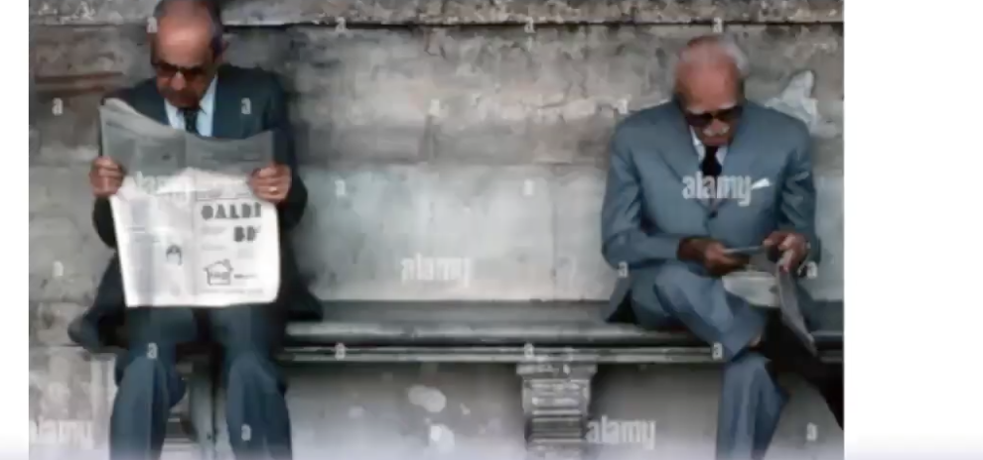

Q2 How do you usually find out about the news?
Q3 Why is it important to read about the news everyday?

PART 3
In this part, I'm going to ask you to compare two pictures, and I will then ask you two questions about them. You will have 45 seconds for each response.
Begin speaking when you hear this sound.
Q1 Describe 2 pictures

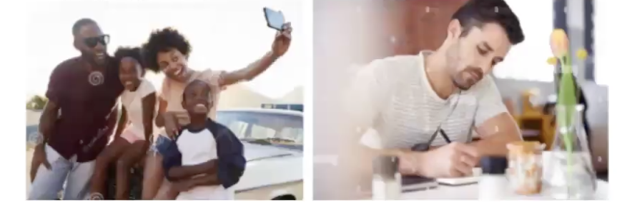

Q2 Do you prefer recording memories by picture or by words? Why?
Q3 Why do people like taking photos with their mobile phones?

PART 4
In this part, I'm going to show you a picture and ask you three questions. You will have one minute to think about your answers before you start speaking. You will have two minutes to answer all three questions.
Begin speaking when you hear this sound. Look at the photograph.

Q1 Tell me about a time you were with someone older or younger than you.
Q2 How do you feel in the situation?
Q3 How do you think different generations can learn from each other?

WRITING

PART 1
You want to join a music club. You have 5 messages from a member of the club. Write short answers (1-5 words) to each message. Recommended time: 3 minutes.
Q1 What is the weather like today?
Q2 What are you wearing today?
Q3 What is your favorite kind of music?
Q4 Which sport is the most popular in your country?
Q5 What do you like doing with your friend?

PART 2
You are a new member of the music club. Fill in the form. Write in sentences. Use 20-30 words. Recommended time: 7 minutes.
Tell us about the last time you went to a museum.

PART 3
You are communicating with other members of the club in the chat room. Reply to their questions. Write in sentences. Use 30-40 words per answer. Recommended time: 10 minutes.

A: I went to the museum at school. How was the time when you visited the museum when you were child?
B: I want to take my children to a museum but I don't know which, the History Museum or Sports Museum. Can you give me advice?
C: Some museums have added technologies like computer screens in their museum and this attracts more visitors. Why?

PART 4:
You are a member of the travel club. You have received this email from the club.

Dear members,
The museums are free of charge but next year museums will require tickets and this might decrease visitors.
What do you think? Make suggestions and explain.

Bests,
Club Manager.

Write an email to your friend. Write about your feelings and what you think the club should do about the situation. Write about 50 words. Recommended time: 10 minutes.

Write an email to the president of the club. Write about your feelings and what you think the club should do about the situation. Write 120-150 words. Recommended time: 20 minutes.

